Hands On Therapeutics

Name:_______________________________ Date:____________________________

Using the symbols, please mark on the diagram where you feel discomfort. Please be as detailed as possible. Feel free to write in any details.

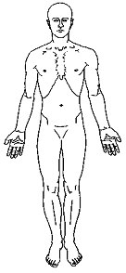
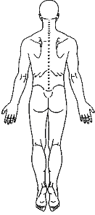
/// Stabbing, Sharp
XXX Burning
000 Pins & Needles
=== Numbness
+++ Aching

Please circle the least and the most amount
of pain you have experienced since your last visit.
Then draw and X over the number representing
the pain you are experiencing right now.

0 1 2 3 4 5 6 7 8 9 10
No Pain Emergency Room

